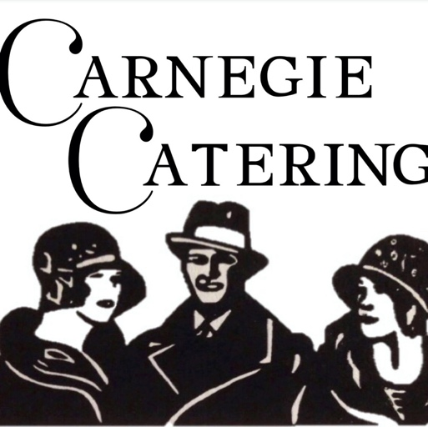

Beverage Packages

3770 Brewerton Road. North Syracuse, NY 13212
(315) 451-1803
www.carnegiecatering.com

All beverages are to be purchased by Carnegie Catering and are to be consumed on the catering event premises

Brand Name substitutes are available for a nominal fee

We would be more than pleased to customize beverage services to meet your needs

CALL FULL OPEN BAR
$30 per guest
(Plus 20% service charge and 8% sales tax)
Bar pricing is based on 4.5 hours
Liquors
Call brands of vodka, gin, whiskey, bourbon, Scotch, rum, and sweet and dry vermouth

Bottled Brews Assorted Bottle Beers
Bottled Wines
Chardonnay, White Zinfandel, Pinot Grigio, Merlot and Cabernet Sauvignon
Accompaniments and Miscellaneous
A variety of sodas, tonic, club soda, orange and cranberry
juice, sour mix, lime juice, bar fruit, and ice

CALL OPEN BAR-A LA CARTE
$17 per guest for the first hour $7 per guest for each additional hour

PREMIUM FULL OPEN BAR
$37 per guest
(Plus 20% service charge and 8% sales tax)
Bar pricing is based on 4.5 hours
Liquors
Grey Goose Vodka, Bombay Sapphire Gin, Makers Mark Whiskey, Captain Morgan Spiced Rum, Chivas Regal Scotch, Two Fingers Tequila, Peach Schnapps,
DiSorrano Amaretto, Kalua, Sweet and Dry Vermouth
Bottled Brews
Assorted domestic and imported beers

Bottled Wines
Chardonnay, Berringer White Zinfandel, Talus Pinot Grigio, Merlot and Cabernet Sauvignon
Accompaniments and Miscellaneous
A variety of sodas, tonic, club soda, orange and cranberry juice, sour mix, lime juice, bar fruit, and ice

PREMIUM OPEN BAR-A LA CARTE
$18 per guest for the first hour $8 per guest for each additional hour

OPEN BEER, WINE, AND SODA BAR
$25 per guest
(Plus 20% service charge and 8% sales tax)
Bar pricing is based on 4.5 hours
Bottled Brews Assorted bottled beers
Bottled Wines
Chardonnay, White Zinfandel, Pinot Grigio, Merlot and Cabernet Sauvignon
Sodas
A variety of regular, diet, and caffeine-free Pepsi products

BEER, WINE, AND SODA BAR-A LA CARTE
$15 per guest for the first hour $5 per guest for each additional hour (Plus 20% service charge, 8% sales tax

Bottled Brews Assorted Bottled Beers
Bottled Wines
Chardonnay, White Zinfandel, Pinot Grigio, Merlot and Cabernet Sauvignon
Sodas
A variety of regular, diet, and caffeine-free Pepsi products

CASH BAR
Your guests pay for each drink as they
receive they receive the.
If the beverage consumption
does not exceed $1,000.00.
The client will be charged the difference.
A $250 bar set-up and a $100
$250.00 bar set-up and $100 bartender
fee will apply

HOST BAR
(Plus 20% management fee and 8% sales tax)
Your guests revive drinks as they would in a cash bar, but the host is charged for each drink.
If the beverage consumption
does not exceed $1,000.00.
The client will be charged the difference.
A $250 bar sset-up and a $100
$250.00 bar set-up and $100 bartender
fee will apply

SODA BAR
(Plus 20% management fee and 8% sales tax)

$3.00 per guest per hour.
A variety of regular, diet, and caffeine- free Pepsi products, and bottled water will be offered

CHAMPAGNE TOAST
Starting at $4.00 per guest Inclusive of Flute Rental

